* **Design a Program for creating machine that accepts the string always ending with 101.**
* **CODE:**

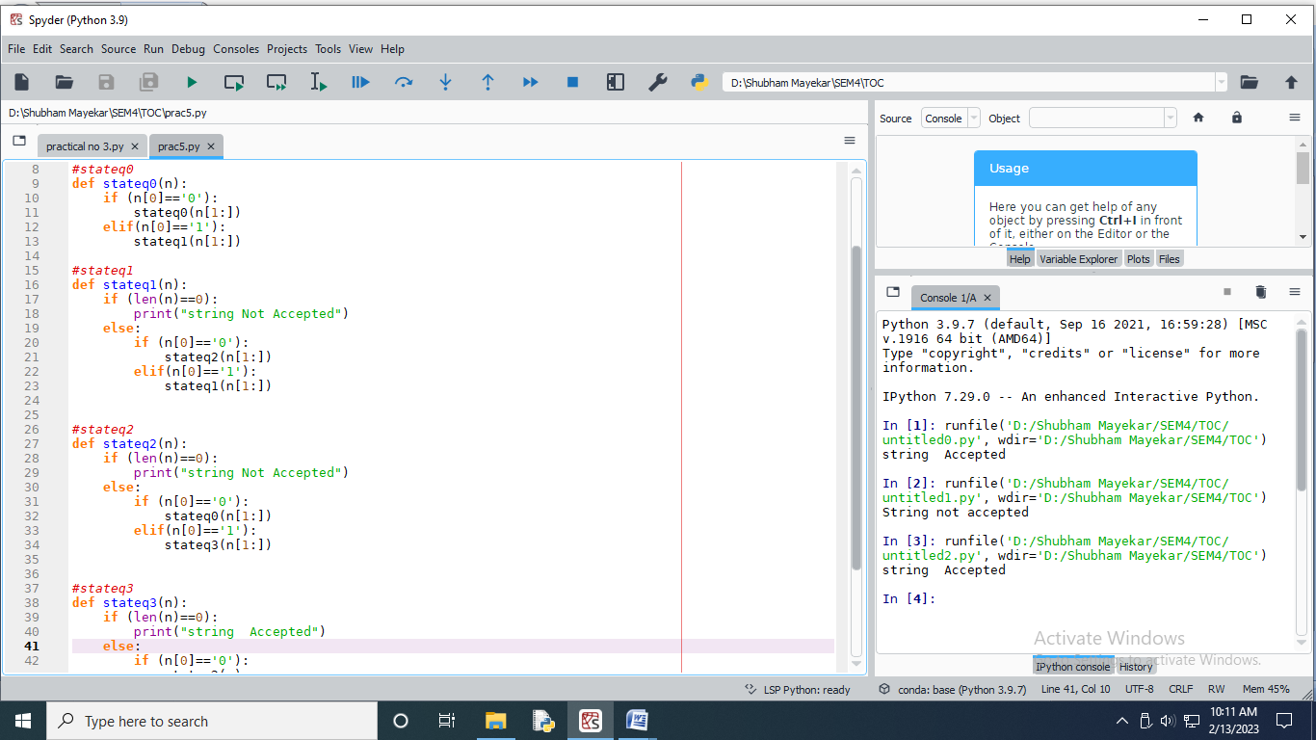

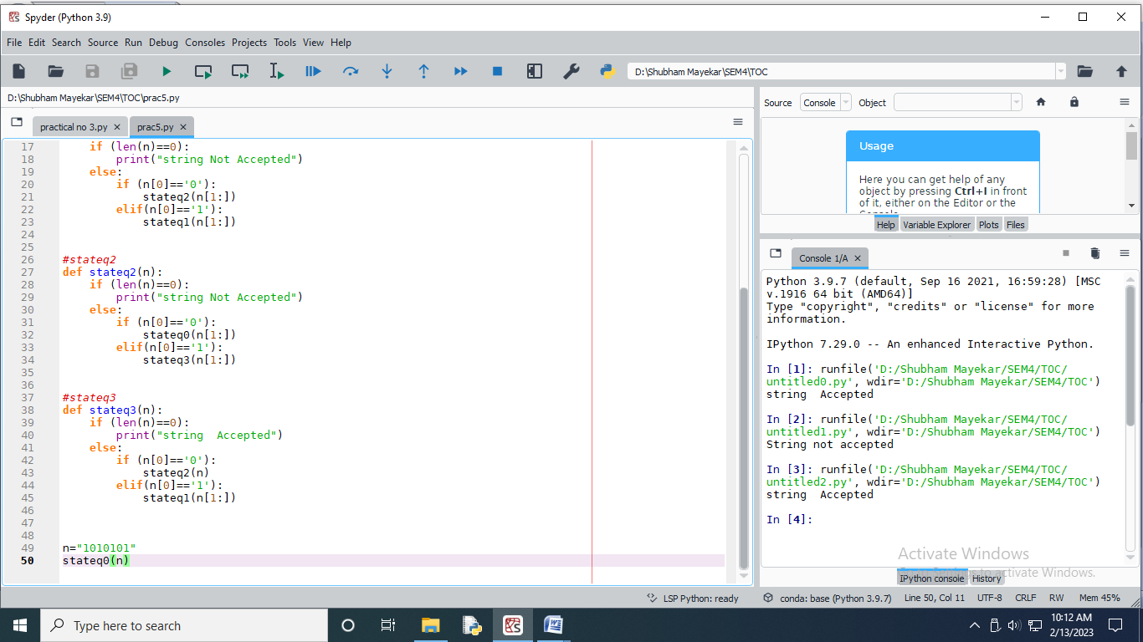

* **OUTPUT:**

